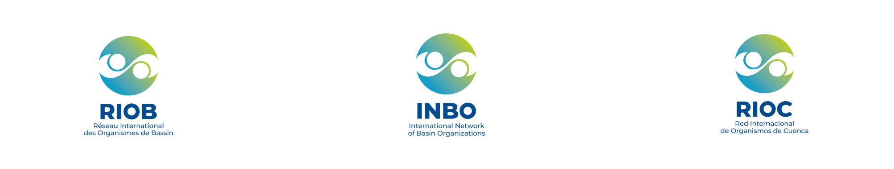
Preliminary proposal for the organization
of the INBO 2028 World Basin Summit
Form to be completed for a preliminary proposal for the 2028 INBO World Basin Summit

Event Profile
- Target Audience: 250 to 500 delegates (representatives of basin organizations, national administrations, local authorities, international financial institutions, UN agencies, technical institutions).
- Delegate Participation: Access to sessions and social events is free. Delegates cover their own travel and accommodation costs.
- Official Languages: English, French, and Spanish, plus the local language of the host country if necessary.
- Format: 100% in-person, over 4 to 5 consecutive days, including:
  - Participatory technical workshops or working meetings, open to all or private, successive or parallel (generally 1 to 1.5 days)
  - 1 high-level political opening session (up to ½ day)
  - 5 thematic plenary sessions (generally 2 days)
  - 1 INBO statutory session (1h30)
  - 2 to 3 parallel technical and cultural visits (½ to 1 day).

Logistics and Practical Organization
- Venue and Equipment: The reception venue must have:
  - A plenary conference room with a capacity of 500 people.
  - At least 3 other conference rooms for workshops and meetings.
  - 1 room for VIPs and bilateral meetings.
  - 1 room for the media and secretariat (equipped with a printer).
  - An exhibition space (for posters or presentations).
  - Sound systems, video projection, and banners for the event, and dedicated spaces for simultaneous interpretation.
  - Preferably, the venue should be easily accessible from the airport or train station where participants will arrive, and close to accommodation.
- Language Services: Ensure simultaneous interpretation in INBO's official languages (English, French, Spanish) and in the local language if necessary.
- Accommodation and Transport:
  - Negotiate preferential rates for delegates at local hotels.
  - Organize local transport (shuttles between airport/train station, hotels, and the event venue) if appropriate (depending on the existence or not of an efficient public transport network).
- Technical and Cultural Visit: Arrange a half-day or full-day visit, integrating technical and cultural elements representative of the host country.
- Social Events: Organize coffee breaks, lunches, and 4 evening receptions (including a welcome cocktail, an official gala dinner, and a closing cocktail), reflecting the local culture.
Communication and Visibility
- Media Mobilization: Collaborate with INBO to engage national and international press and ensure media coverage of the event.
- Logistical Support:
  - Ensure signage, banners, and local announcements at the event site.
  - Arrange for video and photo capture, as well as hybrid or live formats if possible.

_________________________________________________________________________________
Submission deadline: April 30, 2026
Please send to: secretariat@inbo-news.org
Learn more: Call for applications to host the 2028 World Basin Summit - INBO

Form to be completed by the applicant
- Information on the candidate organization
- Candidate country:
- Institution or organization submitting the application:
- Scope of the organization's activities in the field of water resources management (100 to 200 words)
- Address:
- Manager - First name, last name, email address:
- Focal point(s) - First name(s), last name(s), email address(es):
- XX
- XX
- XX
II. Thematic contribution
- Proposals for 1 to 3 thematic priorities to be included in the program, in line with the national and environmental context of the host country.
- XX
- XX
- XX
- Suggestions for national organizations or individuals who could participate (cite the name of the organization or the title/position of the individual considered):
  - during the high-level opening and closing segments (ministers, secretaries of state, etc.):
    - XX
    - XX
  - during thematic sessions (representatives of basin organizations, administrations, experts):
    - XX
    - XX

III. Logistics and practical organization
- Proposed venue(s) where the event could be held:
- Name of proposed venue: XX
  - Address:
  - Brief description/Website:
  - Details on accessibility if not available online:
- XX
- XX

- Proposals for technical and cultural visits (optional, descriptions in a few lines):
- XX
- XX
- XX

