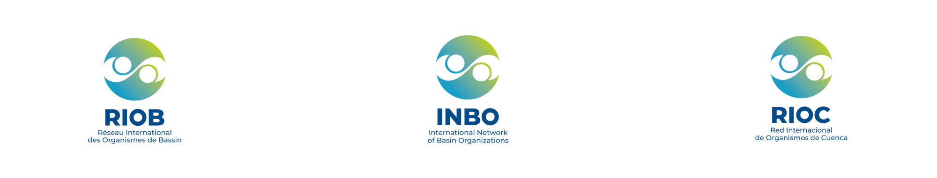
Preliminary proposal for the organization
of the INBO 2028 World Basin Summit
Preliminary proposal for the organization
of the INBO 2028 World Basin Summit

- Information on the candidate organization
- Candidate country:
- Institution or organization submitting the application:
- Scope of the organization's activities in the field of water resources management (100 to 200 words)
- Address:
- Manager - First name, last name, email address:
- Focal point(s) - First name(s), last name(s), email address(es):
- XX
- XX
- XX

II. Thematic contribution
- Proposals for 1 to 3 thematic priorities to be included in the program, in line with the national and environmental context of the host country.
- XX
- XX
- XX
- Suggestions for national organizations or individuals who could participate (cite the name of the organization or the title/position of the individual considered):
  - during the high-level opening and closing segments (ministers, secretaries of state, etc.):
    - XX
    - XX
  - during thematic sessions (representatives of basin organizations, administrations, experts):
    - XX
    - XX

III. Logistics and practical organization
- Proposed venue(s) where the event could be held:
Reminders: The venue must have
- a plenary conference room with a capacity of 500 people,
- at least 3 other conference rooms for workshops and meetings,
- 1 room for VIPs and bilateral meetings,
- 1 room for the media and the secretariat (equipped with a printer)
- an exhibition space (for posters or presentations),
- sound systems, video projection and banners for the event, and dedicated areas for simultaneous interpretation.
Preferably, the venue should be easily accessible from the airport or train station where participants will arrive, and close to accommodation.

- Name of proposed venue: XX
  - Address:
  - Brief description/Website:
  - Details on accessibility if not available online:
- XX
- XX

- Proposals for technical and cultural visits (optional, descriptions in a few lines):
- XX
- XX
- XX

